 

Assignment -3

|  |  |
| --- | --- |
| **Student Name/ID Number:** | Agung Yuda Pratama / 0922-076 |
| **Academic Year:** | 2022 |
| **Unit Assessor:** | Archana Sakpal |
| **Project Title:** | Assignment 3– Spring Boot |
| **Issue Date:** |  |
| **Submission Date:** |  |
| **Internal Verifier Name:** | Archana Sakpal |
| **Date:** | 13-04-2023 |

|  |
| --- |
| **Learner declaration** |
| I certify that the work submitted for this assignment is my own and research sources are fully acknowledged.    14/04/2023  Student signature: Date: |

Let’s build on the previous assignment. (Develop “Know-Your-Neighbourhood”) application. The goal of this application is to provide details on all stores in the user’s neighbourhood.

1. Create a Spring Boot application for “Know-Your-Neighbourhood”.

Click on new and select Spring Starter Project and setting like this

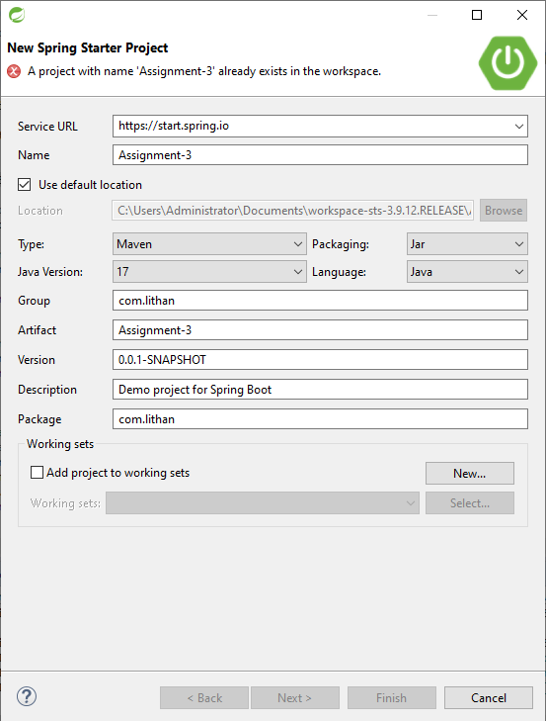

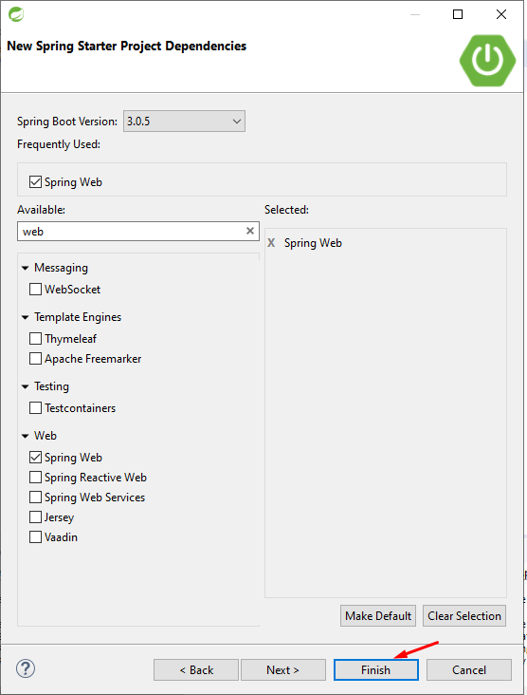

1. Add support for JSP views and create required folder structure.

In the main folder, make a webapp and views folder. Make .jsp right there

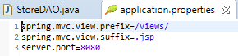

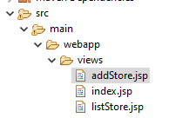

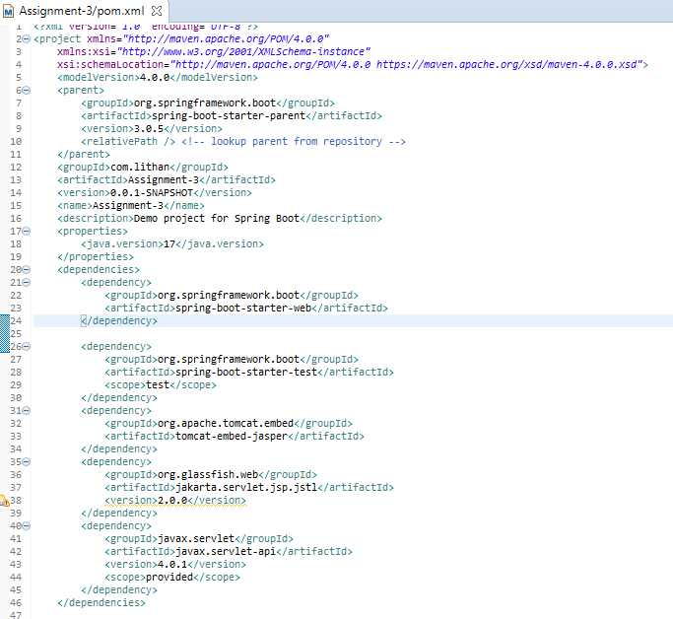

1. Move already developed classes into this project.

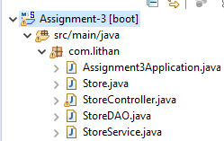

1. Develop all components required to view the stores
   1. Add method to existing Controller class to receive the request to fetch stores

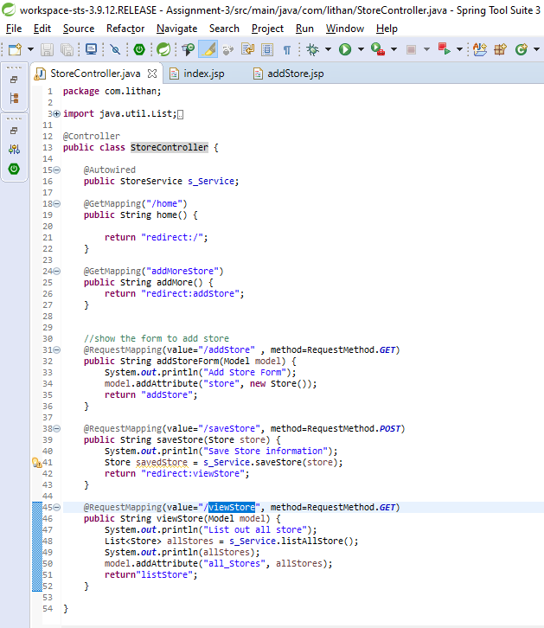

* 1. Add method to existing Service class to process the request (or add method to existing service class)

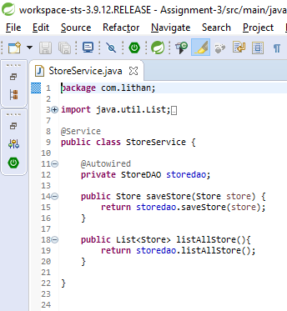

* 1. Add method existing repository class to return all available stores.

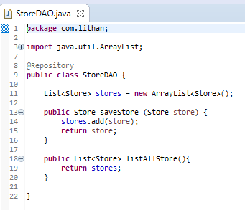

* 1. Create HTML to view the stores. Show name, phone number and localities it serves for each store.

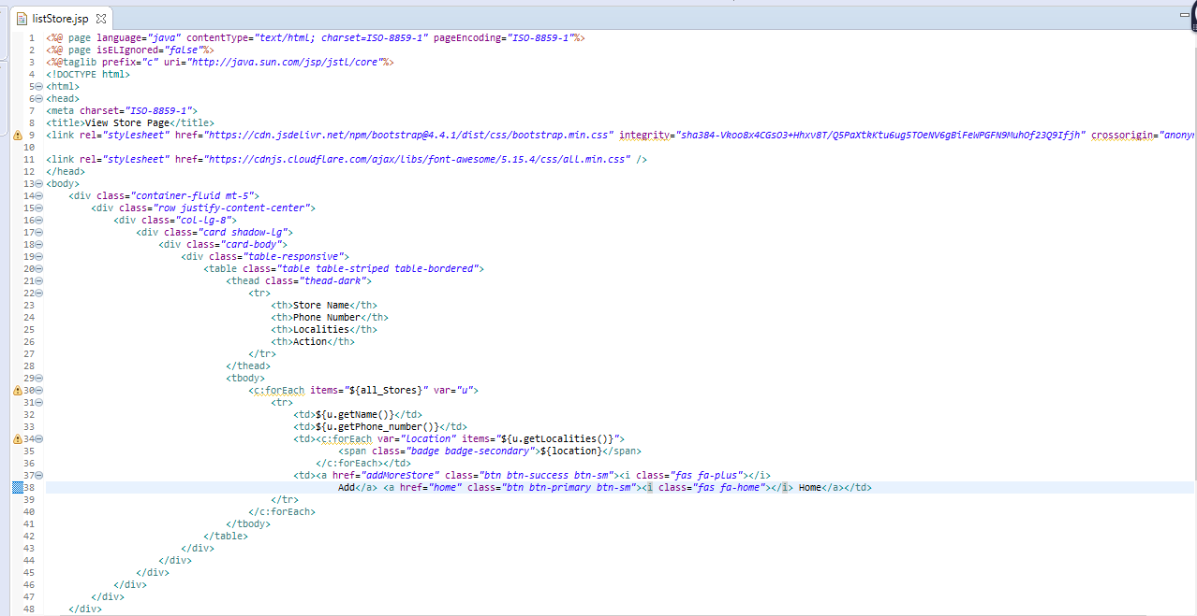

* 1. Ensure that view stores request works end-to-end. (i.e., should be able to submit request to view the stores in the browser and get the page back with all stores).

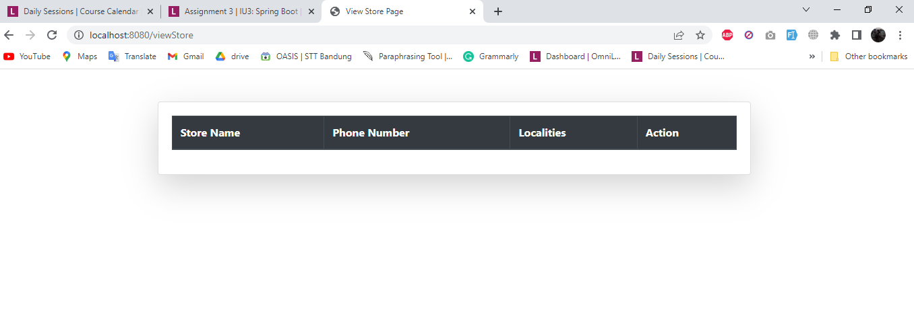

1. Create an HTML page to add a store and link it to the view stores page.

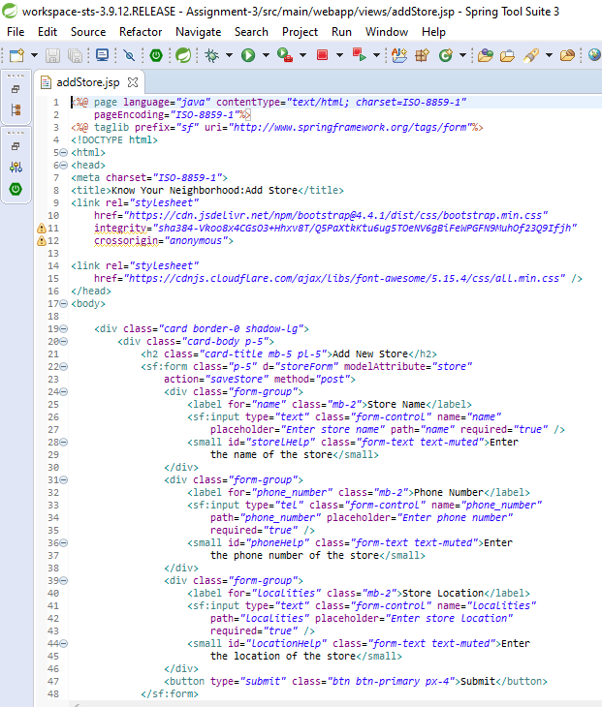

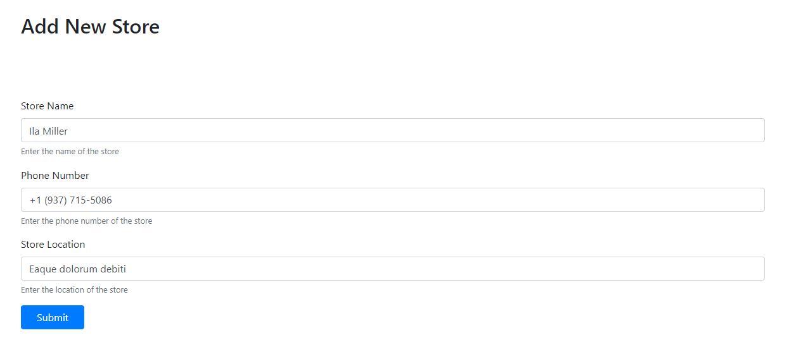

1. Let the response of add request submission be the view page that shows all stores including recently added store.

